

##### AACS1193 Web Design and Development

**Semester 3, 2019/2020**

**Group Assignment**

|  |  |
| --- | --- |
| **Programme : DCN** | |
| **Tutorial Class : Group 1** | |
| **Website Title : DLHM Shoes Shop** | |
| |  |  |  |  |  |  |  |  | | --- | --- | --- | --- | --- | --- | --- | --- | | **No.** | **Student Name** | **Student ID** | **Module In Charge** | **Signature** | **Part A**  **(25%)** | **Part B**  **(75%)** | **Total**  **(100%)** | | **1** | **Melvin Lin Chee Wai** | **19WMD02728** | 1. **Categories** 2. **Login & Sign-up** | **lin** |  |  |  | | **2** | **Lye Jun Onn** | **19WMD01152** | 1. **cart** 2. **social** | **Onn** | | **3** | **Yap Hao De** | **19WMD01565** | **5.Homepage**  **6.About us** | **Yap** | | **4** | **Daniel Wong Vun Chung** | **19WMD00418** | **7.FAQ**  **8.Search** | **dnaiel** | | |
| **Lecturer: Ms Tan Lai Kien** | **Tutor : Mr Tan Lee Kent** |
| **Date of Submission:** | |

**Assessment Rubrics – Assignment Part 1**

|  |  |  |  |  |  |  |
| --- | --- | --- | --- | --- | --- | --- |
| Proposal (Phases of Planning & Designing Web)**Criteria** | **Marks** | **Excellent** | **Good** | **Average** | **Poor** | **Score** |
| **CLO 3: Manage the development of a Web site.** | | | | | | |
| Chapter 1 : Planning   * Description of the organization * Reasons of the Web site * Web site objectives * Potential users * Information the users need * Proposed deliverable | 8 | Excellently define all the required information.  (7 – 8) | Correctly define most of the required information.  (5 – 6) | Correctly define some of the information. The rest are either incorrect or missing.  (3 – 4) | Most of the information is missing, incomplete or incorrect.  (0 – 2) |  |
| Chapter 2: Web Analysis   * Functions or modules * Organization of the Web site | 6 | Excellently define all the required information.  (6 ) | Correctly define most of the required information.  (4 – 5) | Correctly define some of the information. The rest are either incorrect or missing.  (2– 3) | Most of the information is missing, incomplete or incorrect.  (0 – 1) |  |
| Chapter 3: Web Design   * Web page layout and elaboration | 8 | Excellently define all the required information.  (7 – 8) | Correctly define most of the required information.  (5 – 6) | Correctly define some of the information. The rest are either incorrect or missing.  (3 – 4) | Most of the information is missing, incomplete or incorrect.  (0 – 2) |  |
| Report Format   * References & Appendix | 3 | Excellently provide enough references and supporting documents  (3 ) | Correctly provide some references and supporting documents  (2) | Generally provide few references and supporting documents  (1 ) | Not able to provide enough references and supporting documents  (0 ) |  |
| **Total (25 marks)** | | | | | |  |

Comments (if any):

____________________________________________________________________________________________________________________________________________________________________________________________________________________________________________________________________________________________________________________________________

**Assessment Rubrics – Assignment Part 2 (Phases of Implementing Web)**

|  |  |  |  |  |  |  |
| --- | --- | --- | --- | --- | --- | --- |
| **Criteria** | **Marks** | **Excellent** | **Good** | **Average** | **Poor** | **Score** |
| **CLO 2: Demonstrate the web development using web development tool, Cascading Style Sheets (CSS) and JavaScript.** | | | | | | |
| **Functionality & Complexity of the Overall Web Site using the following elements:**   * Media elements (text, graphic, audio, video and animation) * Hypertext and hypermedia * List * Formatting * Hotspot / image map * Table * Form * CSS for all of the GUI design (use External Style Sheet effectively) * JavaScript | **40** | Excellently completed more than 80% of the required functionalities correctly using all the listed elements.  (31 – 40) | Completed more than 60% of the required functionalities correctly using most of the listed elements.  (21 – 30) | Averagely completed more than 40% of the required functionalities with some minor errors. Only used some of the listed elements.  (11 – 20) | Not able to complete most of the required functionalities correctly. Only used few of the listed elements.  (0 – 10) |  |
| **Creativity in Modules’ Function & Interface Design** | **15** | Excellent creativity in module function and interface design.  (13 – 15) | Good creativity in module function and interface design.  (9 – 12) | Average creativity in module function and interface design.  (5 – 8) | Poor creativity in module function and interface design.  (0 – 4) |  |
| **User Interface Features** | **15** | Excellent design consistency and interface usability, visual effect and interactivity.  (13 – 15) | Good design consistency and interface usability, visual effect and interactivity.  (9 – 12) | Average design consistency and interface usability, visual effect and interactivity.  (5 – 8) | Poor design consistency and interface usability, visual effect and interactivity.  (0 – 4) |  |
| **Web Site Consistency with Part 1 (Students are required to justify if there is any inconsistency)** | **5** | Excellent consistent with proposed design.  (5) | Good consistent with proposed design.  (4) | Average consistent with proposed design.  (2 – 3) | Poor consistent with proposed design.  (0 – 1) |  |
| **Total (75 marks)** | | | | | |  |

Comments (if any):

____________________________________________________________________________________________________________________________________________________________________________________________________________________________________________________________________________________________________________________________________

**Plagiarism Statement**

The university college views cases of plagiarism or collusion by students very seriously. Any students who intentionally plagiarize of collude in any part of their assignments/projects or written work threatens the values of academic work and undermines the credibility and integrity of the University College’s awards. Plagiarism or collusion discovered at any stage of the student’s course of study will be dealt with appropriately by the School. Such offender shall appear before a panel of enquiry at the School and appropriate punishment will be meted out. Punishment may include failing the student for the assignment or project, re-submission of another piece of work or downgrading of the work the maximum of a pass grade even if actual grade achieved was higher.

**What constitutes “Plagiarism” and “Collusion”?**

Plagiarism according to the Oxford Advanced Learner’s Dictionary of Current English means “take and use somebody else’s ideas, words, etc as if they were one’s own.”

**Plagiarism** can take the form of reproduction without acknowledgement from published or unpublished works of others including materials download from computer files an Internet.

Student’s work submitted for assessment is accepted on understanding that it is the students’ own effort without falsification of any kind. Acknowledgement to the source must be made if students had replied on any sources for information with appropriate reference being made in their work.

**Collusion** can be deemed to be a form of plagiarism involving the unauthorized co-operation between two or more people with deceptive intention.

Collusion can take the form of two or more students producing a piece of work together but one intentionally passing it off as his work with the knowledge of the others. Student may have submitted the work of another as his own with consent from that other student. In such cases, both parties are guilty of collusion.

**Obligations of students**

Students are required to sign a declaration that the work submitted such as course work assignment, essays and projects, etc is their own work and that they have not in any way knowingly allow another student copy it. It will be assumed that all submitted work is that of the students’ own work.

Students are expected to familiarize themselves with or make use of method(s) of citing other people’s work in accordance with acceptable referencing



**AACS1193 Web Design and Development**

**Plagiarism Statement Form**

**We confirm that the submitted work are all our own work and are in our own words.**

|  |  |  |  |  |  |
| --- | --- | --- | --- | --- | --- |
|  | **Name (Block Capitals)** |  | **Student ID** |  | **Signature** |
|  |  |  |  |  |  |
| **1.** | **MELVN LIN CHEE WAI** |  | **19WMD02728** |  | lin |
| **2.** | **LYE JUN ONN** |  | **19WMD01152** |  | **Onn.** |
| **3.** | **YAP HAO DE** |  | **19WMD01565** |  | **Yap** |
| **4.** | **Danie Wong Vun Chung** |  | **19WMD00418** |  | **daniel** |
| **5.** |  |  |  |  |  |

|  |  |
| --- | --- |
| **Tutorial Group :** | **Group 1** |
| **Date :** |  |

DLHM shoes

**Description of DLHM shoes**

We are DLHM shoes shop. We sell a variety of shoes of men's and women's

footwear. Our shop are also sell on sport shoes. For men, we have sell

sneakers, running shoes, boots, oxford shoes, motorcycle shoes and boat shoes.

For women, we have sell sneakers, running shoes, boots, heels and sandals shoes.

**Reason of developing websites**

### 1. Allow prospective customers to shop where, how, and when they want.

-If there's only one way for customers to purchase your stuff, you're ignoring the percentage of

shoppers willing (and often only willing) to shop differently.Most people choose to shop online

while enjoying the convenience of their own home to minimize travel time and traffic flow.

Digital shopping also allows them to shop where they need to. That includes when your store is

closed. Know your ecommerce store is available at all times. Whatever the person, online

shopping is getting more and more people.

2. Collect the email marketing leads and customer info.

-We know when checking out at a shop, it's hard to gather email addresses and other useful

details. Generally, by not presenting the bid with the details inserted by the clerk, shoppers

who hit the end point frequently decide not to prolong the cycle without considering the deal.

It is more effective to gather information online, since website users will do so at their own

time.

3. Increase information about promotions at the shop.

-Growing store has other promotions and also finds ways of spreading the latest offers.

Another way to market exclusive deals is through your e-commerce shop.

Such promotions are also a perfect way for this post to achieve its first point (collecting email

addresses). Visitors to all of your stores will be alerted to these deals (online and offline)

so that they can take advantage of them. Promotions encourage long-term

business growth by can profits and profitability, as promotions also provide a sign-up stage allowing you to reach these customers for repeat business later on.

**Web site objectives**

The web site objectives are to help the company make sell more efficient and can promote its goods. For the customer, the web site can help them see what product the company are selling and can give them a general idea of what they want to buy. The web site also show where the company shop located is and how to contact them.

**Potential Users**

DLHM Shoes potential users are the users that patronize the famous brand. Our shop’s shoes no matter its price, materials, design, and comfort of shoes are better than other brands. Not only that, our shoes have sold many types of shoes that suitable for all gender, and face for all ages. It means basically the market of our shop is fully envelope. Lastly, a cheaper price that compare with other brands also is the main point that can attract some student and low-income people.

**Information the users need**

The information that DLHM Shoes Shop sell's shoe will show a style code of shoe, price, US size customer that can choose, product details. Style code can give customer online check its is Genuine authorization. US size included size 4 to 11. Product details will show the benefit of shoe, color, and region of origin.

**Proposed Deliverable**

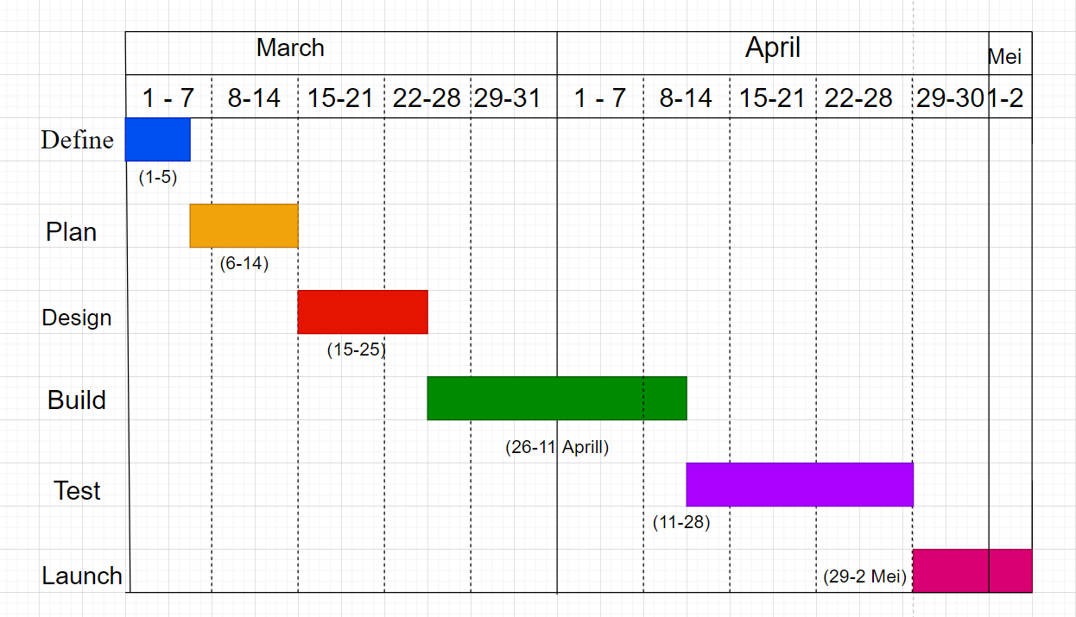

Function or module of DLHM shoes

· Homepage

-Is the first page of the website. This page will show an introduction with all type of shoes product available at the DLHM online shoes shop.

· About us

-To show the description and the reason for developing DLHM online shoes shop website.

· Membership

-Customer can login or sign up to save their details of payment method.

· Search Bar

-To search the type of shoes.

· Category

- This category will classification every type of the shoes, it will make users easier to find what they want

· Cart

-It shows a customer that items wish to buy, and total payment of it

· FAQ

-It records some customer frequently asked question, and the question is all related about the shoes and our shop

· Social

-Here will show facebook, twitter, and Instagram about DLHM Shoes

**Webpage Sketching**

Homepage

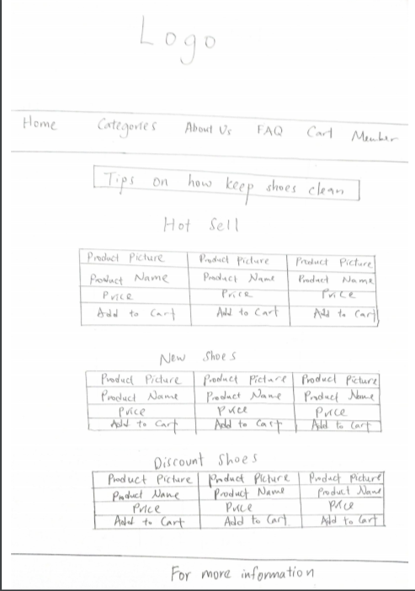

Men, Shoes, Kid, and Sport

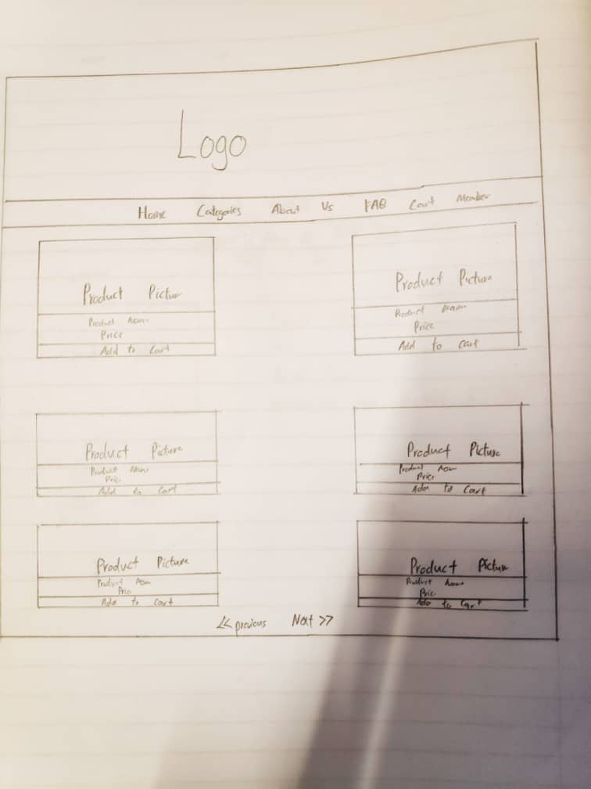

Product Details

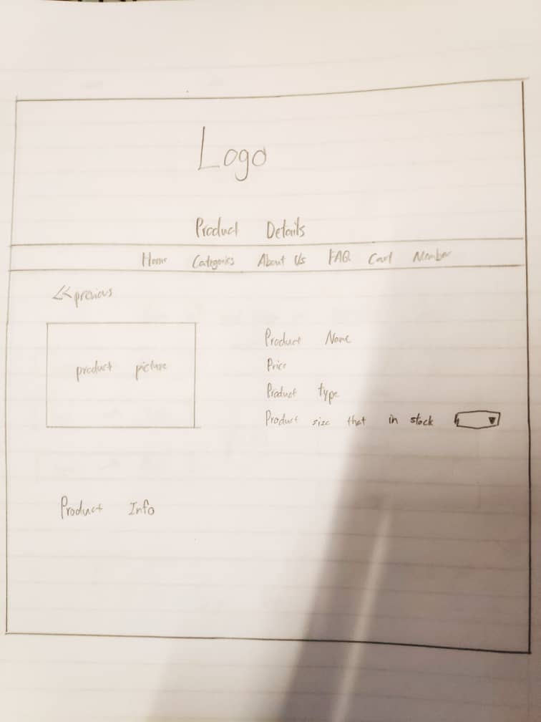

Sign Up

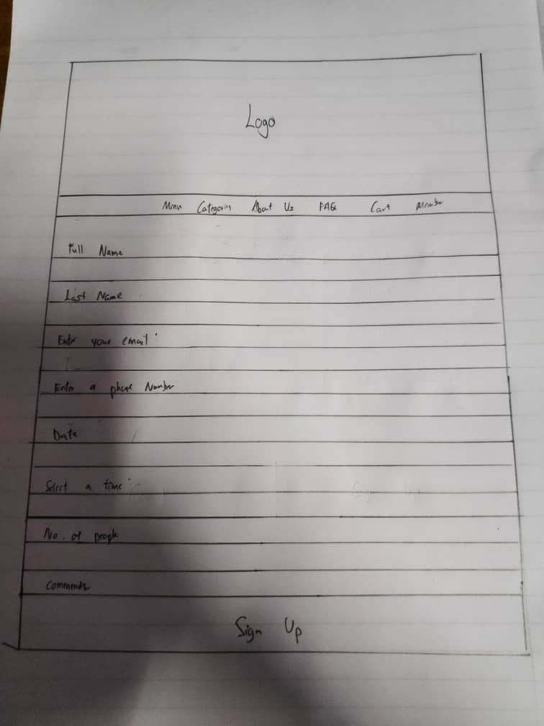

Login

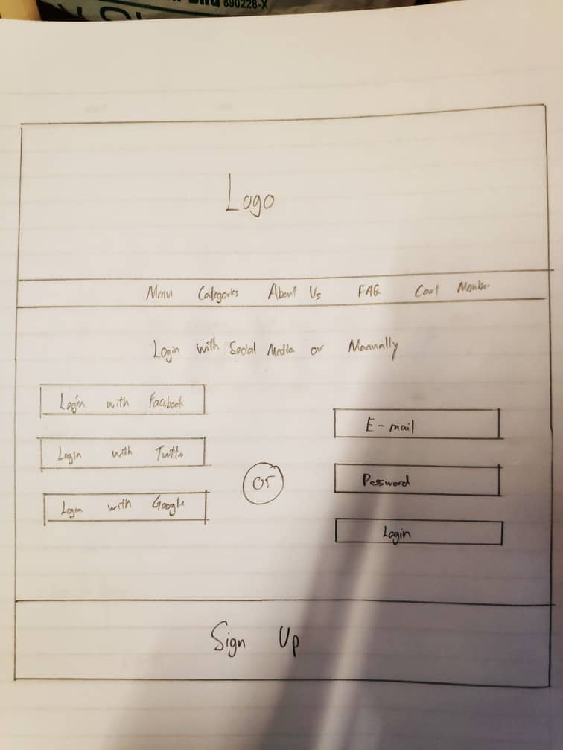

About Us

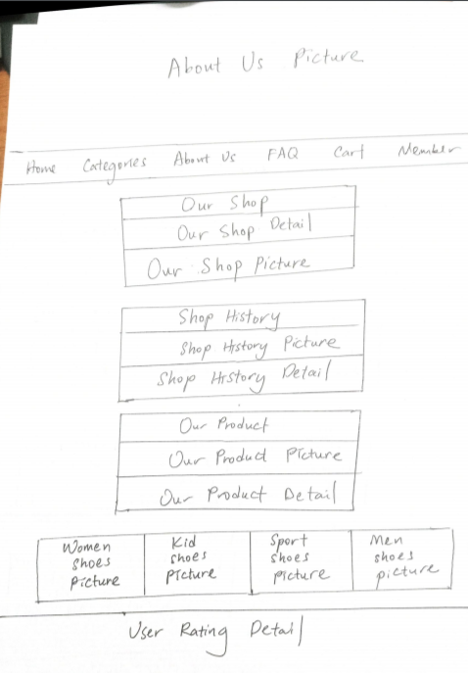

CART

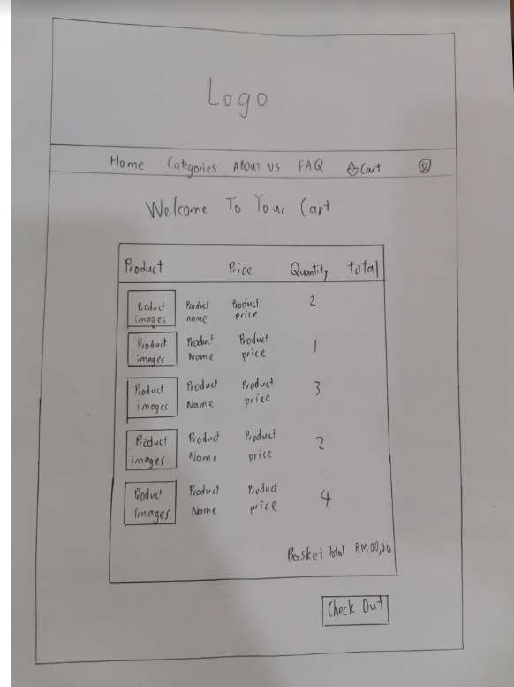

Billing Address and payment

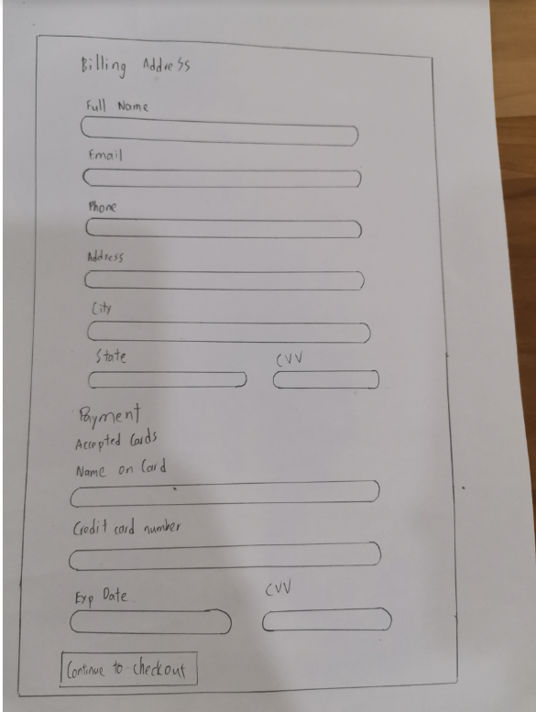

FAQ

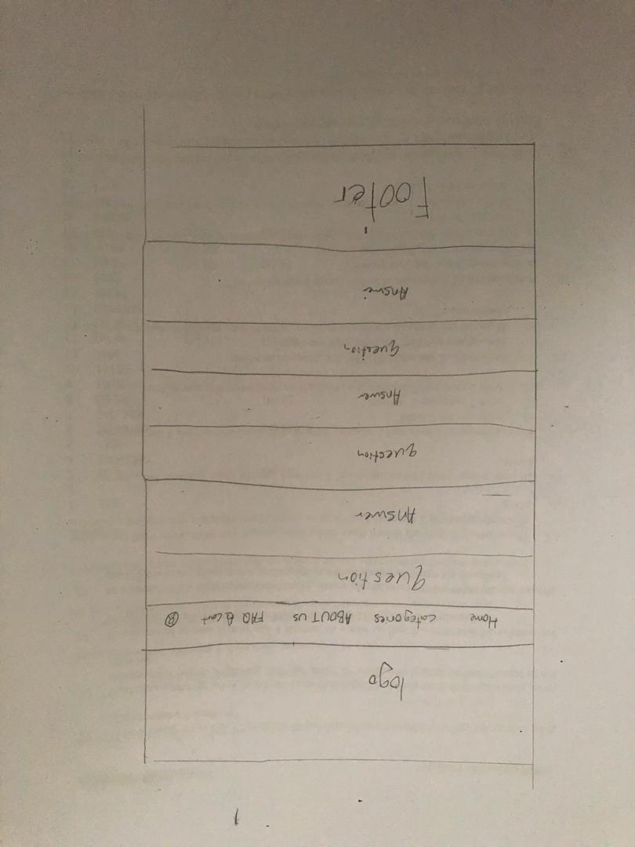

Clean Sneakers Tips

